**Data Testing Assessment**

A school 'Study & Play' has different branches in India. Students appeared in 10th & 12th board have scored good marks in different subjects. 'Study & Play' wants to recognize teachers across different streams to award them for their student's performance.

'Student & Play' are looking for a data warehouse solution to do analysis on student performance in a particular branch or subject.

**Exercise -**

As a part of this exercise, use the below Student data to import in database table.

Sample Data –

|  |  |  |  |  |
| --- | --- | --- | --- | --- |
| Student Name | StudentRollNo | Class | Age | Father's Name |
| AJAY KUMAR | IETLINF01 | X | 16 | PREM KUMAR |
| RAJAT MISHRA | IETLINF02 | XI | 17 | PANKAJ MISHRA |
| SUDHEER SHARMA | IETLINF03 | IX | 15 | SUNDER SHARMA |
| NANCY KAUR | IETLINF04 | XII | 18 | AK SINGH |
| SUMITA SHARMA | IETLINF05 | IV | 14 | AJAY SHARMA |
| NANDINI GUPTA | IETLINF06 | VII | 18 | RAM GUPTA |
| RAM KUMAR | IETLINF07 | X | 16 | RAMAN KUMAR |

Tasks

1. Create above table in database and insert the data.

CREATE TABLE Studentdata (

StudentName varchar(255),

StudentRollNo varchar(255),

StdClass varchar(255),

Age int,

FatherName varchar(255)

);

INSERT INTO Studentdata (StudentName, StudentRollNo, StdClass, Age, FatherName)

VALUES ('SUMITA SHARMA', 'IETLINF05', '1v', 14, 'AJAY SHARMA');

INSERT INTO Studentdata (StudentName, StudentRollNo, StdClass, Age, FatherName)

VALUES ('RAM KUMAR', 'IETLINF07', 'X', 16, 'RAMAN KUMAR');

1. Write sql query to find out total number of students in each class.

1. Write sql query to find out average age of students in each class.

1. Write sql query to find out the number of students having same roll no.
2. 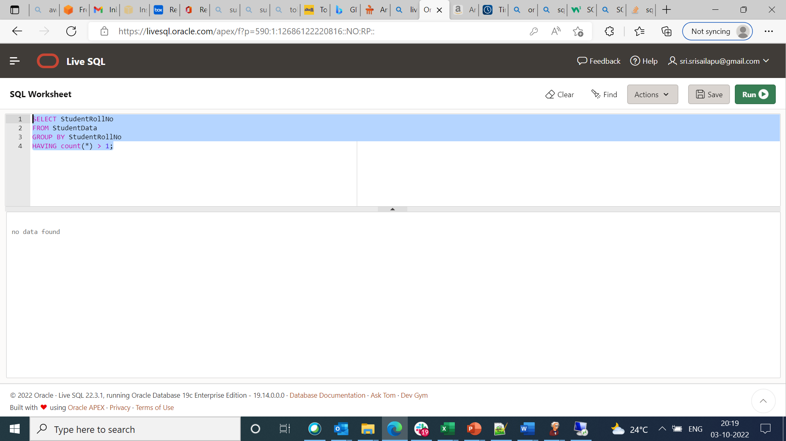
3. Write sql query to view the duplicate name of a student from the table.

